1. Criar uma pasta para guardar as informações.

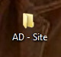

1. Escolher uma imagem que “represente” a intenção do site.

- Site que disponibiliza PDFs de livros

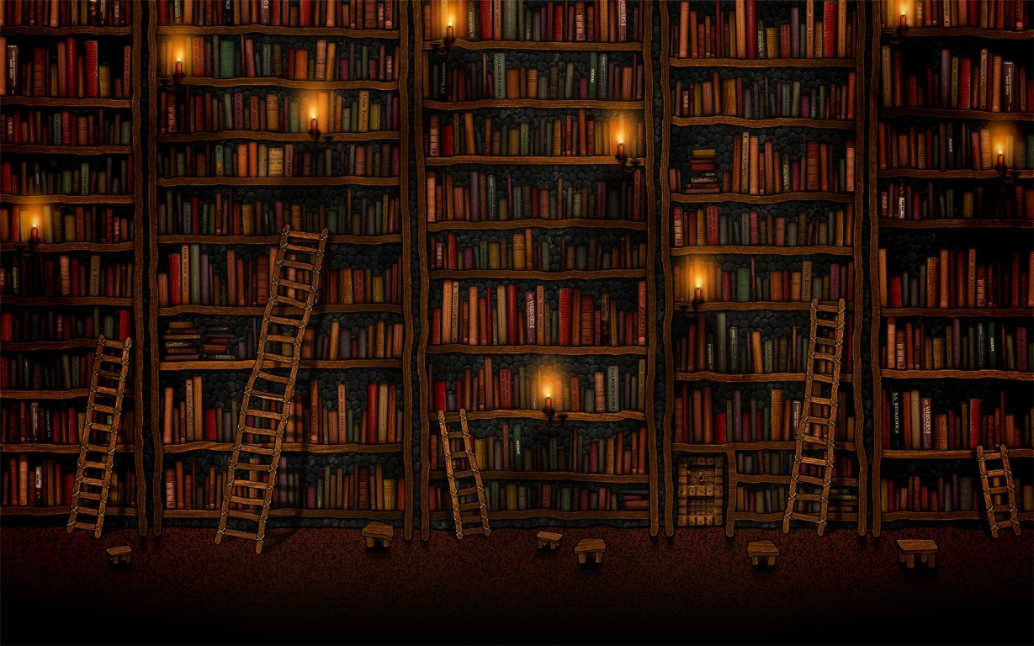

1. Extrair a paleta de cores

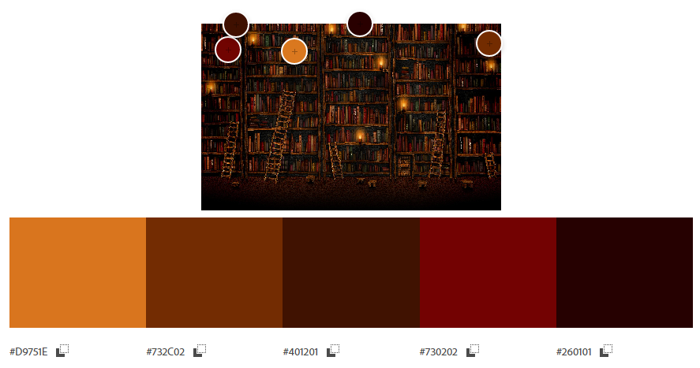

1. Crie um arquivo no Word (Armazenar informações, imagens, fontes – Tipografia do Site)

#D9751E

#732C02

#401201

#730202

#260101

1. Criar um PSD com a paleta de cores

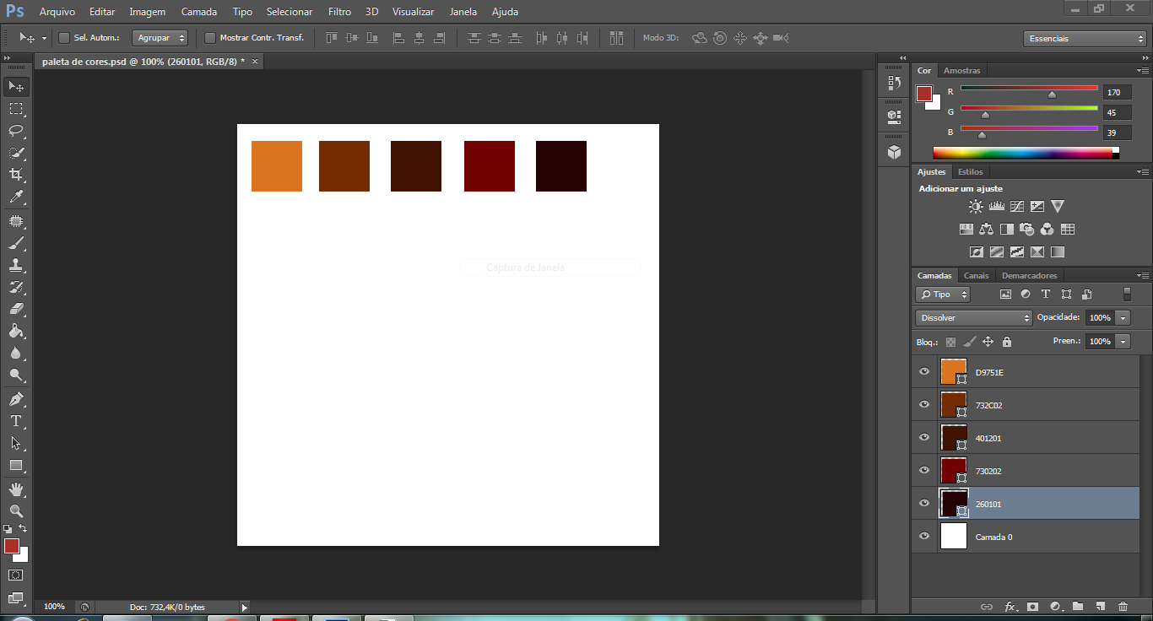

1. Fonte

Link da fonte escolhida: <https://www.dafont.com/pt/yearbook-2.font>

Nome: yearbook

Amostra :

“On the other hand, we denounce with righteous indignation and dislike men who are so beguiled and demoralized by the charms of pleasure of the moment, so blinded by desire, that they cannot foresee the pain and trouble that are bound to ensue; and equal blame belongs to those who fail in their duty through weakness of will, which is the same as saying through shrinking from toil and pain.”